What is BDD?

Full form of BDD is Behaviour Driven Development.

In BDD, users (business analysts/product owners) first write scenarios or acceptance tests that describes the behaviour of the system from the customer's perspective, for review and sign-off by the product owners before developers write their codes.

BDD can be divided into three sections as given below:

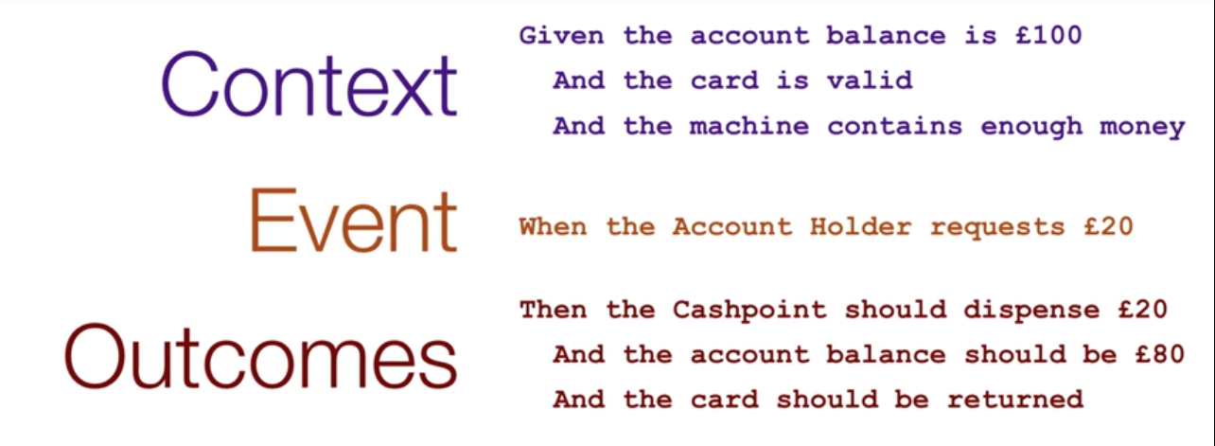
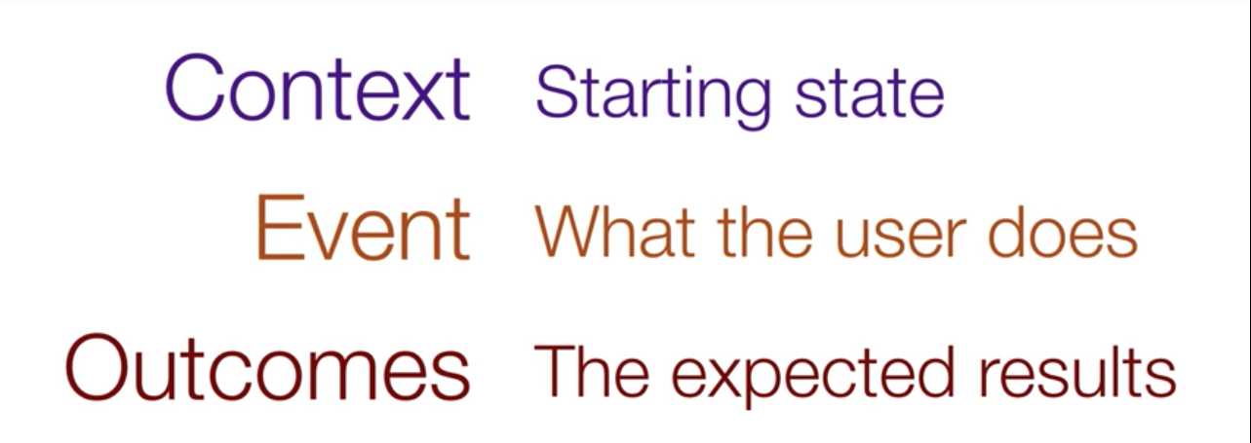

BDD can be defined as a set of behaviours that the user can expect from the system.

While implementing BDD, we can say that “Doing the right thing” compared to TDD (Test Driven Development) which can be described as “Doing the thing right”.

Features of BDD -

- Shifting from thinking in “tests” to thinking in “behaviour”
- Collaboration between Business stakeholders, Business Analysts, QA Team and developers
- Ubiquitous language, it is easy to describe
- Driven by Business Value
- Extends Test Driven Development (TDD) by utilising natural language that non-technical stakeholders can understand
- BDD frameworks such as Cucumber or JBehave are an enabler, acting as a “bridge” in between Business & Technical Language

